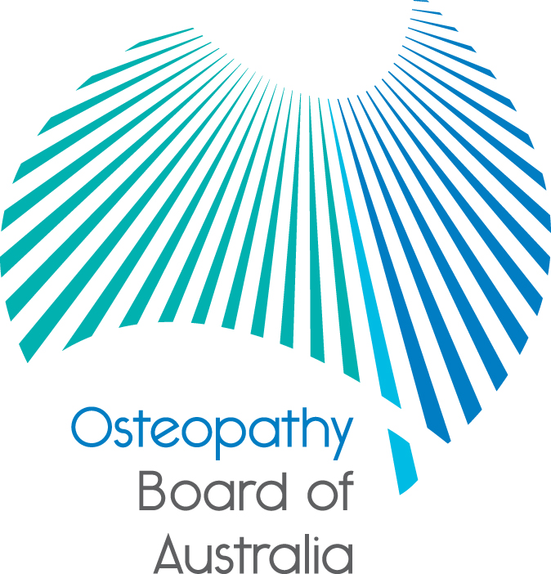
Position statement

Updated: 27 March 2017

Statement on paediatric care
The Osteopathy Board of Australia
The National Registration and Accreditation Scheme (the National Scheme) for health practitioners in Australia commenced on 1 July 2010 under the Health Practitioner Regulation National Law, as in force in each state and territory(the National Law).
Under the National Law, the Osteopathy Board of Australia (the Board) is responsible for the regulation of the osteopaths and is supported in this role by the Australian Health Practitioner Regulation Agency (AHPRA).
The Board has approved registration standards, codes and guidelines which determine the requirements and expectations which guide the professional practice of osteopaths in Australia

The National Scheme has patient safety at its heart, and all health practitioners have a duty to make the care of their patients their first concern and to practise safely and effectively.
Codes and guidelines
The Board’s Code of conduct for osteopaths and Guidelines for advertising of regulated health services are published on its website at www.osteopathyboard.gov.au. These documents, and the Board’s other codes and guidelines, make clear what the Board expects of registered osteopaths as part of the healthcare system.
Osteopathy Board of Australia’s position on paediatric care, the treatment of children and scope of practice for osteopaths
The National Law uses title protection provisions under sections 113 to 118 (title and practice protections) that do not generally restrict scope of practice for osteopaths with a few limited exceptions.
Osteopaths have a responsibility to recognise and work within the limits of their competence and scope of practice.
This applies to all osteopaths whether newly graduated or those who have been practising for many years and for all patient groups, including paediatric patients.
Code of conduct for osteopaths
Section 1.2 of the Board’s Code of conduct for osteopaths says that: ‘Practitioners have a responsibility to recognise and work within the limits of their competence and scope of practice. Scopes of practice vary according to different roles; for example, practitioners, researchers and managers will all have quite different competence and scopes of practice’.
The Code of conduct also states in section 2.2 that ‘Good practice’ involves:
a) recognising and working within the limits of a practitioner’s competence and scope of practice, which may change over time
b) ensuring that practitioners maintain adequate knowledge and skills to provide safe and effective care
c) when moving into a new area of practice, ensuring that a practitioner has undertaken sufficient training and/or qualifications to achieve competency in that area.

The Board considers a registered osteopath’s ‘scope of practice’ as: ‘the professional role and services that an individual health practitioner is educated and competent to perform’.
This means that registered osteopaths can work in areas of practice in which they have education, training, experience and competence.
If registered osteopaths wish to change or develop their scope of practice, they must undertake further education and training to ensure they have the necessary competence.
The Board does not recommend individual post-graduate or continuing education courses to osteopaths, it is up to each practitioner to assess where they need to update their education and learning and complete this prior to changing or extending their scope of practice. The Board expects that any post-graduate or continuing education courses will be evidence-informed and that osteopaths maintain their knowledge through continuing professional development.
Osteopaths should not claim to or provide care for babies and children unless they have the appropriate education, training and competence to do so.
When practitioners do not have the clinical skills and knowledge to appropriately assess and manage a particular paediatric patient, the Board expects them to refer the patient to another healthcare practitioner who has the appropriate skills, or to co-manage the patient with them. This should happen immediately when there are serious conditions that require urgent referral.
Osteopaths with appropriate training and experience to practice in the area of paediatrics cannot use the term ‘specialist’ in relation to their practice or give the impression or advertise that they specialise or are a specialist in paediatrics and treating neonates, infants and young children.
Specialist registration under the National Scheme has only been established in the medical, dental and podiatry professions and these professions can use protected specialist titles. ‘Specialist’ registration and specialist titles have not been established for osteopathy in Australia.
If anyone has a concern about an osteopath
As the national regulation and registration body governing the osteopathy profession, the Board would be very concerned about any practitioner who is not practising osteopathy safely and within the limits of their competency, training and expertise.
Anyone concerned about the health, conduct or performance of an osteopath, can raise their concerns or make a complaint (referred to under the National Law as ‘notifications’) by following the ‘Make a complaint’ link from the Board’s homepage.
All complaints will be assessed by the Board and decisions are guided by the Regulatory principles for the National Scheme.
Complaints about statutory offences, such as an osteopath’s advertising can also be made online to AHPRA or by calling 1300 419 495 or in person at an AHPRA office.
For more information
- Go to the Board’s website at: www.osteopathyboard.gov.au.
- Lodge an online enquiry form.
- For registration enquiries: 1300 419 495 (within Australia) +61 3 9275 9009 (overseas callers).

References to ‘children’ and ‘paediatric’ are terms used interchangeably by the Board to refer to anyone aged under 18.
Different systems exist in New South Wales and Queensland under the National Scheme which are co-regulatory jurisdictions. This means the Board cannot receive complaints about the conduct, performance or behaviour of osteopaths in NSW and Qld. The relevant authorities in these jurisdictions are the Osteopathy Council of NSW and the Office of the Health Ombudsman Queensland.

