

Osteopathy Board of Australia

Registrant data

Reporting period: 1 October 2018 – 31 December 2018

Table of contents
Introduction 3
Principal place of practice 4
1. Registration type 4
1. Endorsements 4
Age group 5
2. Registration type and subtype 5
Gender 6
3. Registration type 6
4. Percentage 6

Introduction
The role of the Osteopathy Board of Australia (the Board) include:
- registering osteopaths and students
- developing standards, codes and guidelines for the osteopathy profession
- handling notifications, complaints, investigations and disciplinary hearings
- overseeing the assessment of overseas trained practitioners who wish to practise in Australia, and
- approving accreditation standards and accredited courses of study.
The Board’s functions are supported by the Australian Health Practitioner Regulation Agency (AHPRA). For information about legislation governing our operations see About AHPRA at www.ahpra.gov.au/About-AHPRA/What-We-Do/Legislation.aspx.
The Board has analysed its registration data and produced a number of statistical breakdowns about registrants to share with the profession and community. The Board shares these breakdowns regularly.
For more information on osteopathy registration, please see the Board’s website: www.osteopathyboard.gov.au/Registration.aspx

Principal place of practice
- Registration type
  - Registration type by principal place of practice
Registration type | ACT | NSW | NT | QLD | SA | TAS | VIC | WA | No PPP | Total
General | 41 | 565 | 3 | 218 | 37 | 48 | 1,403 | 64 | 35 | 2,414
Provisional |  |  |  | 2 |  |  | 3 |  | 1 | 6
Limited |  |  |  |  |  |  |  |  |  | 0
Non-practising |  | 20 |  | 6 | 1 |  | 44 | 1 | 20 | 92
Total | 41 | 585 | 3 | 226 | 38 | 48 | 1,450 | 65 | 56 | 2,512

  - Principal place of practice percentages
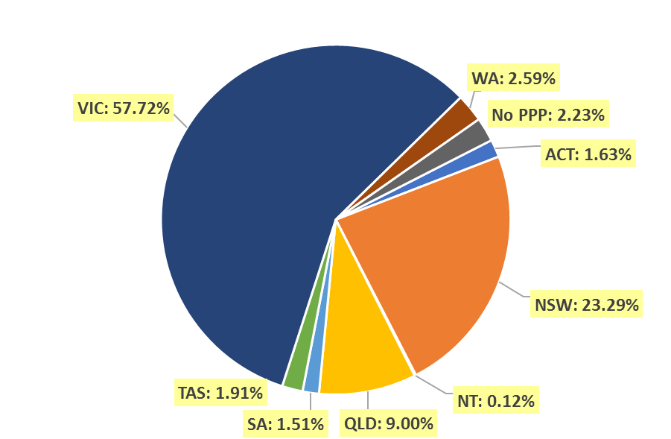

Endorsements
  - Endorsements
Endorsement | ACT | NSW | NT | QLD | SA | TAS | VIC | WA | No PPP | Total
Acupuncture |  |  |  |  |  |  | 2 |  |  | 2

Age group
- Registration type and subtype
  - Registration by age group
Age group | General | Provisional | Limited | Non-practising | Total
U - 25 | 140 | 2 |  | 2 | 144
25 - 29 | 489 | 2 |  | 13 | 504
30 - 34 | 435 | 2 |  | 22 | 459
35 - 39 | 433 |  |  | 16 | 449
40 - 44 | 320 |  |  | 14 | 334
45 - 49 | 210 |  |  | 6 | 216
50 - 54 | 113 |  |  | 2 | 115
55 - 59 | 98 |  |  | 3 | 101
60 - 64 | 79 |  |  | 7 | 86
65 - 69 | 61 |  |  | 3 | 64
70 - 74 | 26 |  |  |  | 26
75 - 79 | 4 |  |  | 3 | 7
80+ | 6 |  |  | 1 | 7
Total | 2,414 | 6 | 0 | 92 | 2,512

  - Registrants by Age Group

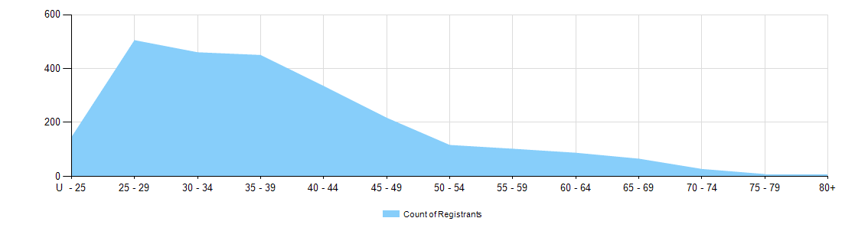

Gender
- Registration type
  - Registration type by gender
Gender | Registration type | ACT | NSW | NT | QLD | SA | TAS | VIC | WA | No PPP | Total
Female | General | 19 | 255 | 1 | 99 | 18 | 27 | 853 | 35 | 20 | 1,327
Female | Provisional |  |  |  | 1 |  |  | 2 |  | 1 | 4
Female | Non-practising |  | 10 |  | 1 |  |  | 28 |  | 13 | 52
Total female |  | 19 | 265 | 1 | 101 | 18 | 27 | 883 | 35 | 34 | 1,383
Male | General | 22 | 310 | 2 | 119 | 19 | 21 | 550 | 29 | 15 | 1,087
Male | Provisional |  |  |  | 1 |  |  | 1 |  |  | 2
Male | Non-practising |  | 10 |  | 5 | 1 |  | 16 | 1 | 7 | 40
Total male |  | 22 | 320 | 2 | 125 | 20 | 21 | 567 | 30 | 22 | 1,129
Total |  | 41 | 585 | 3 | 226 | 38 | 48 | 1,450 | 65 | 56 | 2,512

- Percentage
  - Registration by gender percentages
Gender | ACT | NSW | NT | QLD | SA | TAS | VIC | WA | No PPP | Total
Female | 46.3% | 45.3% | 33.3% | 44.7% | 47.4% | 56.3% | 60.9% | 53.8% | 60.7% | 55.1%
Male | 53.7% | 54.7% | 66.7% | 55.3% | 52.6% | 43.8% | 39.1% | 46.2% | 39.3% | 44.9%

