

Osteopathy Board of Australia

Registrant Data

Reporting period: 1 October 2016 – 31 December 2016

Table of contents
Introduction 3
Principal Place of Practice 4
1. Registration Type 4
2. Endorsements 4
Age Group 5
3. Registration Type and Sub type 5
Gender 6
4. Registration Type 6
5. Percentage 6

Introduction
The role of the Osteopathy Board of Australia (the Board) include:
- registering osteopaths and students
- developing standards, codes and guidelines for the osteopathy profession
- handling notifications, complaints, investigations and disciplinary hearings
- overseeing the assessment of overseas trained practitioners who wish to practise in Australia, and
- approving accreditation standards and accredited courses of study.
The Board’s functions are supported by the Australian Health Practitioner Regulation Agency (AHPRA). For information about legislation governing our operations see About AHPRA at http://www.ahpra.gov.au/About-AHPRA/What-We-Do/Legislation.aspx.
The Board has analysed its registration data and produced a number of statistical breakdowns about registrants to share with the profession and community. The Board shares these breakdowns regularly.
For more information on osteopathy registration, please see the Board’s website: http://www.osteopathyboard.gov.au/Registration.aspx

Principal Place of Practice
- Registration Type
  - Registration type by principal place of practice
Registration Type | ACT | NSW | NT | QLD | SA | TAS | VIC | WA | No PPP | Total
General | 34 | 549 | 3 | 192 | 37 | 45 | 1,160 | 61 | 34 | 2,115
Provisional |  | 6 |  | 3 |  |  | 1 | 1 |  | 11
Non-practising |  | 17 |  | 7 | 2 |  | 39 | 1 | 14 | 80
Total | 34 | 572 | 3 | 202 | 39 | 45 | 1,200 | 63 | 48 | 2,206

  - Registration type by principal place of practice percentages

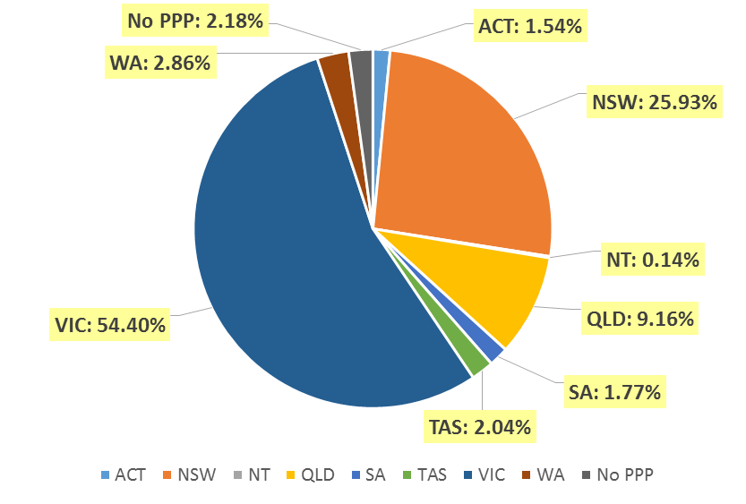

Endorsements
  - Endorsements
Endorsement | ACT | NSW | NT | QLD | SA | TAS | VIC | WA | No PPP | Total
Acupuncture |  |  |  |  |  |  | 2 |  |  | 2

Age Group
- Registration Type and Sub type
  - Registration by age group
Age Group | General | Provisional | Non-practising | Total
U - 25 | 101 | 3 |  | 104
25 - 29 | 416 | 5 | 12 | 433
30 - 34 | 412 |  | 19 | 431
35 - 39 | 387 |  | 17 | 404
40 - 44 | 268 | 2 | 9 | 279
45 - 49 | 163 | 1 | 3 | 167
50 - 54 | 101 |  | 3 | 104
55 - 59 | 104 |  | 5 | 109
60 - 64 | 87 |  | 5 | 92
65 - 69 | 47 |  | 2 | 49
70 - 74 | 17 |  |  | 17
75 - 79 | 7 |  | 4 | 11
80+ | 5 |  | 1 | 6
Total | 2,115 | 11 | 80 | 2,206

  - Registrants by Age Group

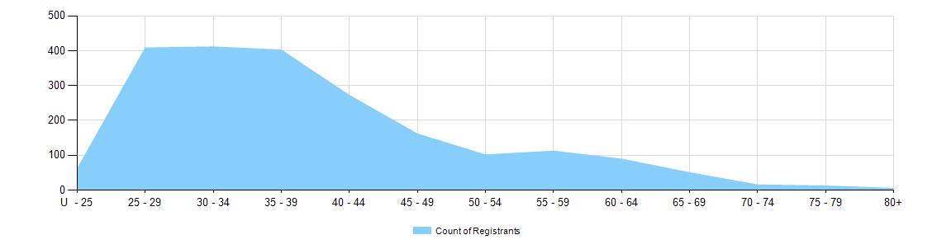

Gender
- Registration Type
  - Registration type by gender
Gender | Registration Type | ACT | NSW | NT | QLD | SA | TAS | VIC | WA | No PPP | Total
Female | General | 15 | 242 |  | 86 | 24 | 25 | 710 | 30 | 14 | 1,146
Female | Provisional |  | 4 |  | 2 |  |  |  | 1 |  | 7
Female | Non-practising |  | 7 |  | 4 |  |  | 31 |  | 9 | 51
Total Female |  | 15 | 253 |  | 92 | 24 | 25 | 741 | 31 | 23 | 1,204
Male | General | 19 | 307 | 3 | 106 | 13 | 20 | 450 | 31 | 20 | 969
Male | Provisional |  | 2 |  | 1 |  |  | 1 |  |  | 4
Male | Non-practising |  | 10 |  | 3 | 2 |  | 8 | 1 | 5 | 29
Total Male |  | 19 | 319 | 3 | 110 | 15 | 20 | 459 | 32 | 25 | 1,002
Total |  | 34 | 572 | 3 | 202 | 39 | 45 | 1,200 | 63 | 48 | 2,206

- Percentage
  - Registration by Gender Percentages
Gender | ACT | NSW | NT | QLD | SA | TAS | VIC | WA | No PPP | Total
Female | 44.1% | 44.2% |  | 45.5% | 61.5% | 55.6% | 61.8% | 49.2% | 47.9% | 54.6%
Male | 55.9% | 55.8% | 100% | 54.5% | 38.5% | 44.4% | 38.3% | 50.8% | 52.1% | 45.4%

