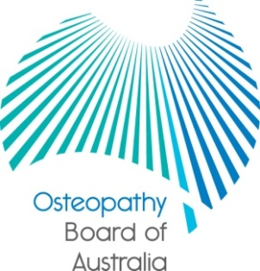

Communiqué

24 April 2014 meeting of the Osteopathy Board of Australia
The 56th meeting of the Osteopathy Board of Australia (the Board) was held on 24 April 2014 in Melbourne. This communiqué outlines the issues discussed and decisions made by the Board at its meeting and other points of interest. The Board publishes this communiqué on its website and emails it to a broad range of stakeholders.

Public consultation on a review of the following registration standards
The Board commenced public consultation on the review of three of its registration standards:
- Professional Indemnity Insurance (PII) arrangements registration standard
- Continuing Professional Development (CPD) registration standard
- Recency of practice registration standard
Please provide written submissions as a Word document (not PDF) by email, marked ‘Consultation - registration standards' to osteoboardconsultation@ahpra.gov.au by close of business 30 June 2014.
The Board will publish submissions received on its website under Past Consultations to encourage discussion and inform the community and stakeholders, unless requested otherwise, or there are circumstances under which submissions may not be published.
Provisional registration
The Board introduced the competent authority pathway in January 2014 for eligible registered osteopaths from the United Kingdom who wish to register in Australia. At the April meeting, the Board considered the first application for provisional registration to undertake a period of supervised practice for six months.

Three year review

The Australian Health Ministers’ Workforce Council has published the terms of reference for the three-year review of the National Registration and Accreditation Scheme. Kim Snowball has been appointed to independently lead the review. Kim has held a variety of senior leadership roles in both the public and private health sectors.
The full terms of reference for the review are available for download here. But in short the three-year review will examine:
- the extent to which AHPRA and National Boards are meeting the objectives and guiding principles of the National Scheme
- the operational performance of the National Scheme
- the National Law, including mandatory reporting, the Australian Health Workforce Advisory Council and new professions entering the scheme
- governance effectiveness, including within the National Scheme and with our key stakeholders,
- the sustainability of the National Scheme, with a specific focus on new professions in the Scheme and funding for smaller professions.

Keeping in touch with the Board
The Board publishes a range of information about registration and the Board’s expectations of practitioners on its website at www.osteopathyboard.gov.au. Osteopaths are encouraged to refer to the site for news and updates on policy and guidelines affecting their profession.

Dr Robert Fendall (Osteopath)
Chair
2 May 2014

