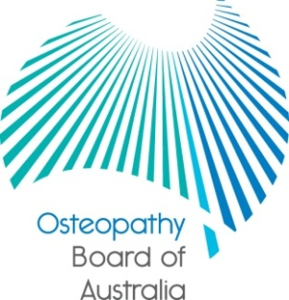

Communiqué

24 July 2014 meeting of the Osteopathy Board of Australia
The 59th meeting of the Osteopathy Board of Australia (the Board) was held on 24 July 2014 in Sydney. This communiqué outlines the issues discussed and decisions made by the Board at its meeting and other points of interest. The Board publishes this communiqué on its website and emails it to a broad range of stakeholders.
Meeting with the Osteopathy Council of NSW
The Osteopathy Board and the Osteopathy Council of New South Wales met on 25 July 2014 in Sydney to discuss issues of mutual interest in a co-regulatory jurisdiction, including common regulatory functions outcomes and challenges.
National Boards consult on practitioners with blood borne infectious diseases
The Osteopathy Board, together with the other National Boards, is inviting feedback on guidelines on the regulatory management of health practitioners with blood borne infectious diseases. Under the draft guidelines, registered health practitioners with blood borne infectious diseases must comply with the Communicable Diseases Network of Australia (CDNA) guidance on this issue to ensure their practice does not compromise patient safety.

The National Boards have published a consultation paper, which is accessible from the Current Consultations page on the Board’s website. The consultation is open until 26 September 2014.

Health Profession Agreement and fees
The Health Profession Agreement (HPA) between the Board and AHPRA is being finalised and will be published on the Board’s website shortly. It sets out the services that AHPRA will provide to support the Board to regulate osteopaths. The HPA will provide information about the Board’s financial operations and fees.
Quarterly registration data
The Board publishes quarterly data profiling Australia’s osteopathy workforce.
At June 2014, there were a total of 1,865 registered osteopaths comprising the following number of registrants according to registration type:
- 1,791 – general registration
- 1 – provisional registration, and
- 73 – non-practising registration.

The quarterly registration data at June 2014 for the osteopathy profession will be published shortly on the Statistics page on the Board’s website. It will include a number of statistical breakdowns.

Keeping in touch with the Board
The Board publishes a range of information about registration and the Board’s expectations of practitioners on its website at www.osteopathyboard.gov.au. Osteopaths are encouraged to refer to the site for news and updates on policy and guidelines affecting their profession.

Dr Robert Fendall (Osteopath)
Chair
1 August 2014

The Osteopathy Board of Australia is the regulator of osteopaths in Australia and acts to protect the public by ensuring that suitably qualified and competent osteopaths are registered. The Board is responsible for developing registration standards, codes and guidelines for osteopaths and managing notifications (complaints)* about osteopaths and osteopathy students. The Board does this through its powers under the Health Practitioner Regulation National Law, as in force in each state and territory, and the National Registration and Accreditation Scheme, supported by the Australian Health Practitioner Regulation Agency (AHPRA). The Board’s work in regulating Australia’s osteopaths in the public interest is underpinned by regulatory principles, which encourage a responsive, risk-based approach to regulation.
*Except in NSW and Queensland which have co-regulatory arrangements.

