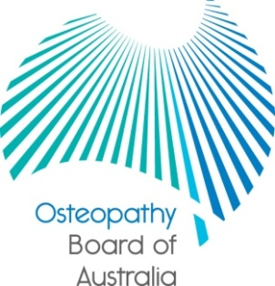

Communiqué

30 August 2013 meeting of the Osteopathy Board of Australia
The 48th meeting of the Osteopathy Board of Australia (the Board) was held on 30 August 2013 in Melbourne. This communiqué outlines the issues discussed and decisions made by the Board at its meeting and other points of interest. The Board publishes this communiqué on its website and emails it to a broad range of stakeholders.
National Registration and Accreditation Scheme 2013 combined meeting
The National Board meeting was held to coincide with the annual National Registration and Accreditation Scheme combined meeting.
The combined meeting is an annual event to encourage learning through sharing ideas, innovation and networking. The goal is to help us to better understand and respond to our wider regulatory and reform environment.
The combined meeting was attended by members of all of the National Boards, NSW Councils’ representatives, the Agency Management Committee, AHPRA staff and accreditation and regulatory authorities from New Zealand.
Competent authority pathway
After further public consultations on a revised Framework: pathways for registration of overseas-trained osteopaths, the Board considered the submissions from stakeholders and members of the public at this meeting. The Board will introduce a competent authority pathway later in 2013. There is a media release on the Board’s website and further information will be provided on implementation in the coming months.
The Board was pleased with the response to all stages of consultation. The Board will publish submissions on this closed consultation at: www.osteopathyboard.gov.au/News/Past-Consultations.aspx.

Consultations
The Board’s registration standards, guidelines and codes that have been in place since the commencement of the NRAS scheme on 1 July 2010 are currently being reviewed. As part of the review process the Board will release the revised documents for consultation which provides an opportunity for registrants and other stakeholders to provide feedback on these documents.
The Board, together with other National Boards will soon be commencing public consultation on the following two registration standards that are common, or largely common, to all National Boards:
- English Language Skills Registration Standard (largely common), and
- Criminal History Registration Standard (common).

Other standards and guidelines, including the Board’s Recency of practice registration standard; Continuing professional development registration standard and guidelines; and Professional Indemnity Insurance arrangements registration standard will be progressively published for consultation later in the year and you will be notified when they are released.

Keeping in touch with the Board
The Board publishes a range of information about registration and the Board’s expectations of practitioners on its website at Osteopathy Board of Australia. Osteopaths are encouraged to refer to the site for news, registration data, newsletters, and updates on policy and guidelines affecting their profession.

Dr Robert Fendall (Osteopath)
Chair
11 September 2013

