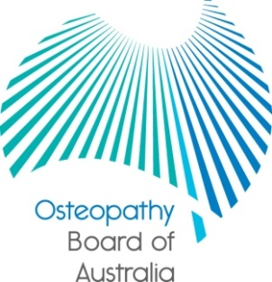

Communiqué

27 February 2014 meeting of the Osteopathy Board of Australia
The 54th meeting of the Osteopathy Board of Australia (the Board) was held on 27 February 2014 in Melbourne. This communiqué outlines the issues discussed and decisions made by the Board at its meeting and other points of interest. The Board publishes this communiqué on its website and emails it to a broad range of stakeholders.
Expression of interest process for appointment as member of a panel
The Australian Health Practitioner Regulation Agency (AHPRA) on behalf of the Board is calling for expressions of interest from experienced practising osteopaths interested in being included on a List of Approved Persons for appointment to panels.
Under the National Law, a National Board convenes health panels and performance and professional standards panels when required to hold hearings into specific health, performance or conduct matters for individual registered health professionals. Such panels consist of members chosen from a National Board list of persons that are approved for appointment to panels.
Further information regarding the expression of interest process is published on the AHPRA website and applications close on 21 March 2014.
Newsletter
The Board has released its latest edition of the electronic newsletter: Registrant update. The newsletter is sent by email to registered osteopaths. It is also published on the Board’s website.
New professional standards for practitioners
In February the National Board published revised and new standards, codes and guidelines which will come into effect on 17 March 2014:
- revised Guidelines for advertising regulated health services
- revised Guidelines for mandatory notifications
- revised Code of conduct, and
- new Social media policy.

All registered health practitioners will need to meet these new standards. The media release on the Board’s website has links to the early versions of the new documents and fact sheets and FAQs. The Board will also focus on providing further information to osteopaths on these documents in its next newsletter.
Quarterly data
One of the benefits of the national registration and accreditation scheme is that there are now national registers where information is published publish about every registered health practitioner in Australia. It is now possible to produce accurate reports on the number of practitioners registered in each profession in Australia. The latest quarterly report is now available on the Board’s website under ‘news’ and ‘statistics’. All the Boards publish similar information about their health profession which is available on each Board’s website.

Keeping in touch with the Board
The Board publishes a range of information about registration and the Board’s expectations of practitioners on its website at www.osteopathyboard.gov.au. Osteopaths are encouraged to refer to the site for news and updates on policy and guidelines affecting their profession.

Dr Robert Fendall (Osteopath)
Chair
3 March 2014

The Health Practitioner Regulation National Law, as in force in each state and territory (the National Law)

