Osteopathy registrant data: December 2014
Published March 2015

Introduction
The role of the Osteopathy Board of Australia (the Board) include:
- registering osteopaths and students
- developing standards, codes and guidelines for the osteopathy profession
- handling notifications, complaints, investigations and disciplinary hearings
- overseeing the assessment of overseas trained practitioners who wish to practise in Australia, and
approving accreditation standards and accredited courses of study.
The Board’s functions are supported by the Australian Health Practitioner Regulation Agency (AHPRA). For information about legislation governing our operations see About AHPRA at http://www.ahpra.gov.au/About-AHPRA/What-We-Do/Legislation.aspx.
The Board has analysed its registration data and produced a number of statistical breakdowns about registrants to share with the profession and community. The Board shares these breakdowns regularly.
For more information on osteopathy registration, please see the Board’s website http://www.osteopathyboard.gov.au/Registration.aspx

Contents
Osteopathy practitioners – registration type and sub type by state or territory 3
Osteopathy practitioners – percentage by principal place of practice 3
Osteopathy practitioners – endorsement by principal place of practice 4
Osteopathy practitioners – registration type and sub type by age group 4
Osteopathy practitioners – by age group 5
Osteopathy practitioners – registration type and sub type by gender 6
Osteopathy practitioners – percentage by gender 6

Osteopathy practitioners – registration type and sub type by state or territory
Osteopathy practitioner |  | Principal place of practice
Registration type | Registration sub type | ACT | NSW | NT | QLD | SA | TAS | VIC | WA | No PPP | Total
General |  | 33 | 532 | 1 | 172 | 35 | 42 | 999 | 61 | 24 | 1,899
Provisional |  | 1 | 3 |  | 4 |  | 1 | 2 |  |  | 11
Limited | Postgraduate training or supervised practice |  |  |  |  |  |  |  |  | 1 | 1
 | Public interest
Non-practising |  |  | 18 |  | 4 | 2 | 1 | 38 |  | 9 | 72
Total |  | 34 | 553 | 1 | 180 | 37 | 44 | 1,039 | 61 | 34 | 1,983

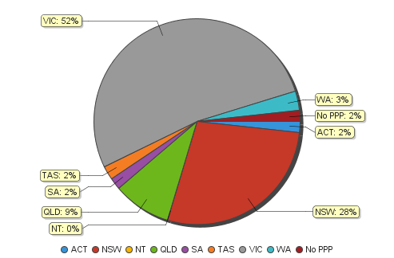
Osteopathy practitioners – percentage by principal place of practice

Osteopathy practitioners – endorsement by principal place of practice
Osteopathy practitioners | Principal place of practice
Endorsement type | ACT | NSW | NT | QLD | SA | TAS | VIC | WA | No PPP | Total
Acupuncture |  |  |  |  |  |  | 2 |  |  | 2

Osteopathy practitioners – registration type and sub type by age group
Osteopathy practitioners |  | Registration type/ Sub type
Age group | General |  | Provisional | Limited |  | Non-practising
 |  |  |  | Postgraduate training or supervised practice | Public interest |  |  |  |  | Total
U - 25 | 101 |  | 2 |  |  |  | 1 |  |  | 104
25 - 29 | 362 |  | 6 |  |  |  | 8 |  |  | 376
30 - 34 | 393 |  | 2 | 1 |  |  | 21 |  |  | 417
35 - 39 | 336 |  | 1 |  |  |  | 19 |  |  | 356
40 - 44 | 228 |  |  |  |  |  | 6 |  |  | 234
45 - 49 | 128 |  |  |  |  |  | 2 |  |  | 130
50 - 54 | 100 |  |  |  |  |  | 2 |  |  | 102
55 - 59 | 101 |  |  |  |  |  | 4 |  |  | 105
60 - 64 | 84 |  |  |  |  |  | 3 |  |  | 87
65 - 69 | 30 |  |  |  |  |  | 2 |  |  | 32
70 - 74 | 23 |  |  |  |  |  | 2 |  |  | 25
75 - 79 | 7 |  |  |  |  |  | 1 |  |  | 8
80+ | 6 |  |  |  |  |  | 1 |  |  | 7
Total | 1,899 |  | 11 | 1 |  |  | 72 |  |  | 1,983
Osteopathy practitioners – by age group
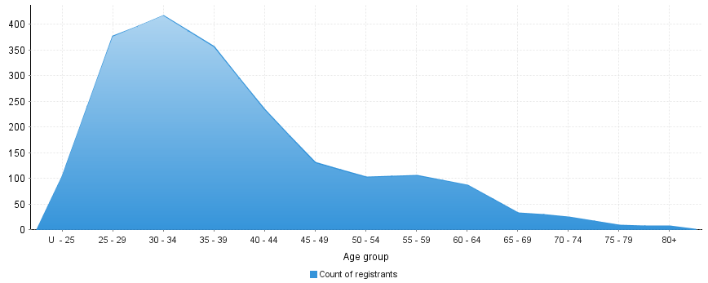
Age group | U - 25 | 25 - 29 | 30 - 34 | 35 - 39 | 40 - 44 | 45 - 49 | 50 - 54 | 55 - 59 | 60 - 64 | 65 - 69 | 70 - 74 | 75 - 79 | 80+
Count of registrants | 104 | 376 | 417 | 356 | 234 | 130 | 102 | 105 | 87 | 32 | 25 | 8 | 7

Osteopathy practitioners – registration type and sub type by gender
Osteopathy Practitioner |  |  | Principal place pf practice
Gender | Registration type | Registration sub type | ACT | NSW | NT | QLD | SA | TAS | VIC | WA | No PPP | Total
Female | General |  | 15 | 225 |  | 73 | 24 | 25 | 613 | 31 | 8 | 1,014
 | Provisional |  |  | 2 |  | 1 |  |  | 2 |  |  | 5
 | Limited | Postgraduate training or supervised practice |  |  |  |  |  |  |  |  | 1 | 1
 |  | Public interest
 | Non-practising |  |  | 7 |  | 3 |  | 1 | 28 |  | 8 | 47
Sub Total |  |  | 15 | 234 |  | 77 | 24 | 26 | 643 | 31 | 17 | 1,067
Male | General |  | 18 | 307 | 1 | 99 | 11 | 17 | 386 | 30 | 16 | 885
 | Provisional |  | 1 | 1 |  | 3 |  | 1 |  |  |  | 6
 | Limited | Postgraduate training or supervised practice
 |  | Public interest
 | Non-practising |  |  | 11 |  | 1 | 2 |  | 10 |  | 1 | 25
Sub Total |  |  | 19 | 319 | 1 | 103 | 13 | 18 | 396 | 30 | 17 | 916
Total |  |  | 34 | 553 | 1 | 180 | 37 | 44 | 1,039 | 61 | 34 | 1,983

Osteopathy practitioners – percentage by gender
Osteopathy practitioners | Principal place of practice
Gender | ACT | NSW | NT | QLD | SA | TAS | VIC | WA | No PPP | Total
Female | 44.12% | 42.31% | 0.00% | 42.78% | 64.86% | 59.09% | 61.89% | 50.82% | 50.00% | 53.81%
Male | 55.88% | 57.69% | 100.00% | 57.22% | 35.14% | 40.91% | 38.11% | 49.18% | 50.00% | 46.19%

